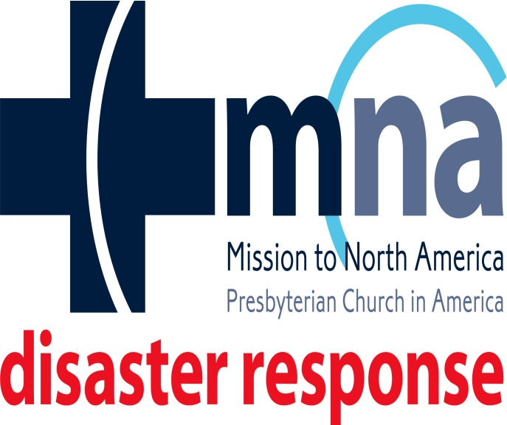
With Gods Help We Will OVERCOME!

April 15, 2020

We are all fighting to defeat Coronavirus, but there is more trouble on the horizon.
It is storm season.
Disaster Response wants you, your families and your church prepared ahead of time for whatever this season may bring.
This reminds us of the need to be prepared. Our hopes are that different teams form among our churches to ensure preparedness in the future. Disaster Response is always ready, willing and able to visit your church to conduct preparedness and readiness classes after the virus has passed. Just contact me, by any means, to schedule a workshop or seminar.
If you have any questions regarding Disaster Response, please don’t hesitate to call me at 804-980-4356 or reach me by email at: mwillettmnaspecialist@gmail.com
The horse is made ready for the day of battle, but victory rests with the Lord. Proverbs 21:31 NIV

In Christ's Service,
Mark Willett
MNA Disaster Response Specialist
Mid-Atlantic

